**CS518 : Computer Vision**

**Report**

**Assignment - 1**

**Prashant Mittal**

**2020CSB1113**

**Task 1 :**

* The procedure followed for this task was as follows :
  1. Gaussian Blur
  2. Sobel Filter
  3. Non maximum Suppression
  4. Double Threshold
  5. Hysteresis
* The **Gaussian Blur** uses a **kernel of size 5x5 and sigma = 2**.
* The low and high threshold values are used to determine the strong and weak pixels in the image after non maximum suppression in the double threshold function.
* The values of the threshold were picked by hit and trial with an idea of its usual range, the function was run on some images and the result was compared with the inbuilt functions and then these two thresholds were selected.
* For higher values of threshold the edges were less and for lower threshold values there were a large number of edges which were irrelevant.
* **Low threshold = 0.04**
* **High threshold = 0.09**

**Task 2 :**

* Laplacian Filter has been implemented to check if an image is Blur or not because the Laplacian kernel when convolved with the original image gives us the value at each pixel how much it is changing with respect to its neighbors.
* If there is rapid change in the slope then the image has no noise but if there is very little or no change that means there is noise and the pixels have almost the same values due to that noise(e.g. Defocused blur, motion blur).
* We can measure that change in pixels using second derivative i.e. Laplacian operator, here we convolve the image with a matrix [[0,1,0] [1,-4,1] [0,1,0]] and we get the desired result.
* Now the variance of the image gives the change in the overall matrix of image, if the image had been sharp there would have been a lot of changes and the variance would be high, but in case of blur image it would be less, while in an image which is constant throughout its pixels would have the variance as zero.
* A threshold is selected so that the value of variance below the threshold is considered to be the variance of a blur image and above it to be that of a sharp image.
* After running on around 100 sharp images and 100 blur images of the same kind using the function **dataset()** defined in **Task2.py**, it was found that the threshold was somewhere near 0.01, hence the value 0.01 is taken as the threshold value. There is no sharp distinction between blur and unblur images; it's just a threshold so that the function can distinguish.
* **Threshold for variance = 0.01**
* Next, the distance between the variance of an image and the threshold is considered for finding the probability of the image being blur or not blur.
* It can be seen from plot (a) that most of the images' variance lie below 0.01 and in plot (b) most of those images lie above 0.01.

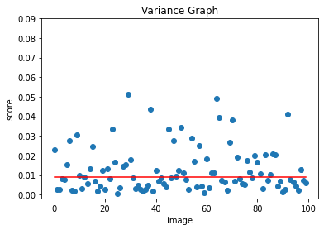 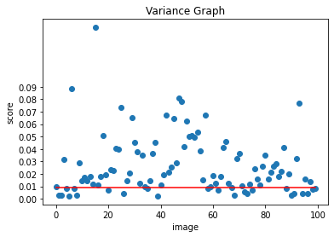

1. Blur images variance (b) Not blur images variance

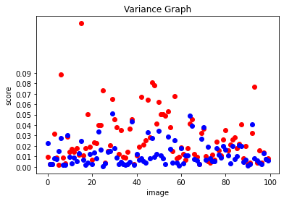

(c) Images variance (Red - Not Blur, Blue - Blur )